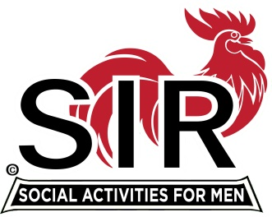
Las Trampas Branch 116
BEC Meeting Agenda
December 20, 2021, 8:30 AM via Zoom
[Zoom login at the bottom of the agenda]
The Mission of SIR is to enhance the lives of our members through fun activities, events and luncheons – while making friends for life.

8:30 am Call to order; Secretary confirm a quorum
8:35 Secretary –Paul Ramacciotti – Approval of Nov 15, 2021 BEC meeting minutes
8:40 Treasurer –/Alan Fitzgerald – Report
8:45 Standing Reports
- Membership – Phil Goff
- RAMP Department Head Reports:
- Recruitment
- Activity Coordinator
- Member relations
- Publicity
- Covid Compliance [Kevin Donahue]

9:00 Big SIR Report – Sam Beret

Storage Rental with Branch 8 and 146

California imposed a statewide mask mandate for indoor public places regardless of vaccination status. The mask mandate goes into effect Wednesday December 15, 2021 and will remain in place until Jan. 15, 2022.

9:10 Old Business
January 2022 Meeting location

9:15 New Business
1- Budget for 2022
2- Boundary Oak contract

9:30 Little SIR Report - Fred Wachowicz
Goals for 2022

9:45 Big SIR - Thank you BEC!

9:50 Adjourn; Next BEC Meeting January 17, 2022

Zoom Link:

https://us02web.zoom.us/j/89269854543
Meeting ID: 892 6985 4543
Passcode: 826904

Dial-in: (669) 900-9128

